In this project, we will be studying the probability of having more than 10 active users at a time. This is equal to 1 minus the probability of having less than 10 active users at a time.

$$P=1- \sum_{k=0}^{10}{\left({N \atop k}\right)p^{k}{\left(1-p\right)}^{N-k} }$$

**I. P varying between 0.01 and 0.99**

N=35;

p=[0.01:0.01:0.99];

for l=[1:length(p)]

for k=[1:1:11]

x(k) = nchoosek(N,k-1).*(p(l)^(k-1)).*(1-p(l)).^(N-k+1);

end

sum(x);

Prob1(l)= 1-sum(x);

end

plot(p,Prob1)

xlabel('Probability')

ylabel('Probability of having more than 10 active users at a time')

title ('Probability of having more than 10 active users at a time while varying p between 0.01 and 0.99')

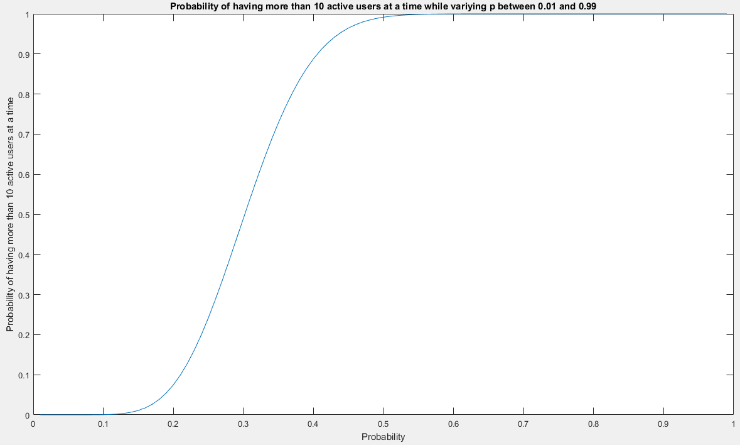

Figure1: Probability of having more than 10 active users at a time while varying p between 0.01 and 0.99

**II. P=0.1, P=0.5 and P=0.9 with N varying between 0 and 100**

P=0.1;

N=[1:100];

for l=[1:length(N)]

if N(l)> 10

for k=[1:1:11]

x(k) = nchoosek(N(l),k-1).*(P^(k-1)).*(1-P).^(N(l)-k+1);

end

else

x = 1;

end

sum(x);

Prob1(l)= 1-sum(x);

end

P=0.5;

for l=[1:length(N)]

if N(l)> 10

for k=[1:1:11]

x(k) = nchoosek(N(l),k-1).*(P^(k-1)).*(1-P).^(N(l)-k+1);

end

else

x = 1;

end

sum(x);

Prob2(l)= 1-sum(x);

end

P=0.9;

for l=[1:length(N)]

if N(l)> 10

for k=[1:1:11]

x(k) = nchoosek(N(l),k-1).*(P^(k-1)).*(1-P).^(N(l)-k+1);

end

else

x = 1;

end

sum(x);

Prob3(l)= 1-sum(x);

end

plot (N,Prob1,N,Prob2,N,Prob3)

xlabel('Number of N ')

ylabel('Probability of having more than 10 active users at a time')

title ('Probability of having more than 10 active users at a time while Fixing P at 0.1, 0.5 and 0.9 and varying N between 0 and 100')

legend('p=0.1', 'p=0.5', 'p=0.9')

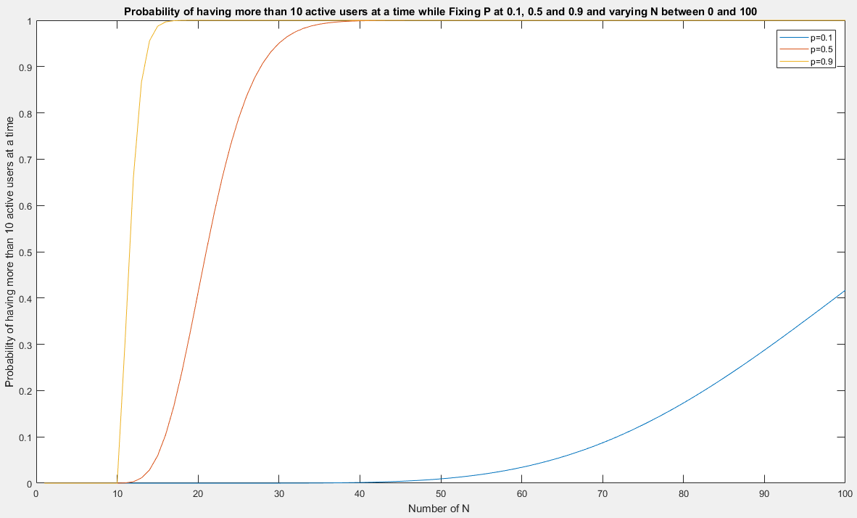

Figure2: Probability of having more than 10 active users at a time while Fixing P at 0.1, 0.5 and 0.9 and varying N between 0 and 100

**III. P=0.1, N=200 and $K_{T}$ varying between 10 and 50**

N=200;

p=0.1

K=[10:1:50];

for a=[1:length(K)]

for k=[1:1:a]

x(k) = nchoosek(N,k-1).*(p^(k-1)).*(1-p).^(N-k+1);

end

sum(x);

Prob(a)= 1-sum(x);

end

plot(K,Prob)

xlabel('Kt')

ylabel('Probability of having more than 10 active users at a time')

title ('Probability of having more than 10 active users at a time while varying Kt between 10 and 50')

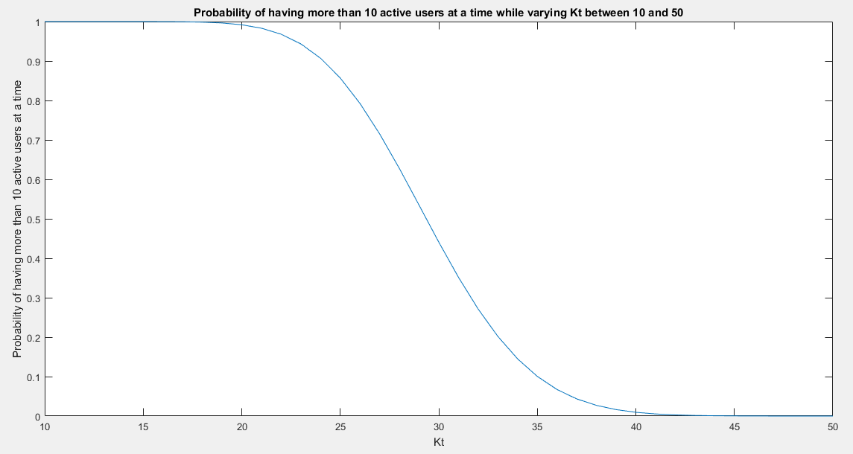

Figure3: Probability of having more than 10 active users at a time while Fixing P at 0.1, and N at 200 while varying $K_{T}$ between 10 and 50

**IV. Discussion**

Figure1 shows that when probability that a user is active increases, the probability of finding more than 10 users at a time increases also. The Plot shows also that if the probability that a user is active is above 0.5, the probability of finding 10 users active at a time is approximately equal to 1.

Figure2 shows that for the same number of users N varying from 0 to 100, the probability of finding 10 users active at a time varies according to the probability that a user is active. If the probability that a user is active is high, the probability of finding 10 users active at a time will reaches 1 before the plot taking the probability that a user is active is lower than the other. The three curves also start to rise after N=10 even if the probability that a user is active is high (p=0.9). This proves that the probability of finding 10 users active at a time is approximately zero.

Figure3 shows that while varying the number of users, that we wish to calculate their probability of being active at the same time, increases, their probability decreases since the probability that a user is active is small (p=0.1).